Experience
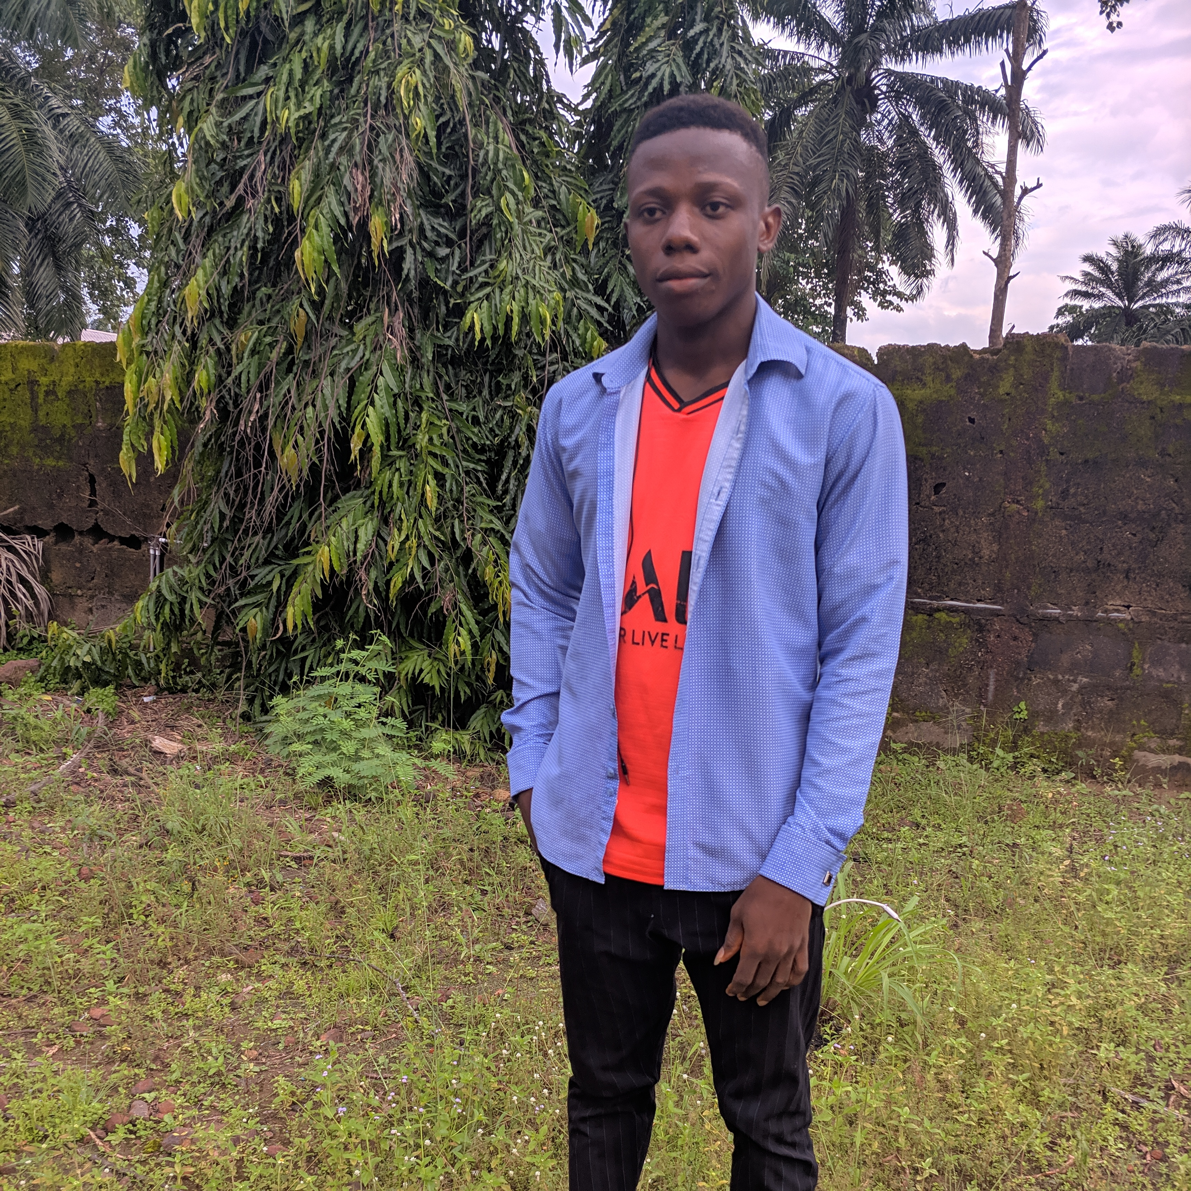

HISWILL
  - web developer/graphic designer

Objective
To secure a responsible career opportunity to fully utilize my training and skills, while making significant contribution to the success of the company.

Skills & Abilities
HTML, CSS, Javascript, React, graphic design, basic knowledge in UI/UX design

Vitals
Agbama Housing Estate Umuahia
Tel: +2349155819622
Email: irogbulamgodswillenyinnaya@gmail.com

ntelitix,enugu nigeria

2020-2022
Graphic Designer for ntelitix

exellent computer technology

2019-2020
Computer IT/Training

Education

2017 – 2021

b.ed computer engineering

University Of Nigeria Nsukka

2010 -2016
SECONDARY SCHOOL

Model Secondary School Mpu Enugu Nigeria

COMMUNICATION
Fluent With English

REFERENCES

krix communication ventures

krixcyber12@gmail.com

